**Project report**

## Jiweon Park

300281074

Brief description of the first report 2

Home page layout & CSS style 3

Home page 4

Studying Page 4

School Page 6

Living Page 6

About us page 7

Summary 8

Source 9

# Brief description of the first report

* Page layout
  + Home page
  + Studying in Vancouver page
    - Explains advantages of studying in Vancouver, Tuition fee for international students, and how to get a study permit
  + Living in Vancouver page
    - Includes four sections about information - Explanations of transportation, accommodation, food & restaurant.
  + Schools in Vancouver page
    - Divided into 4 sections about school information and transfer system in B.C
  + + About me page added
    - About me and a google map that points Douglas college location
* Targeted People :
  + International students

1. who study in Vancouver but are not used to living.
2. who want to study in Vancouver from around the world.
3. who are looking for some information about Vancouver schools.

* Characteristics of the website :

As international students are not familiar with English-written websites, it has many images and media resources for them to understand easier.

It functions as a useful locator website that connects to informative websites.

# Home page layout & CSS style

1. Homepage layout

As main homepage and content pages’ design are different, main homepage is used for grid column whereas content is used as a grid-template-area

<Main homepage layout grid > <Content homepage layout grid >

MainHome

Grid-column : 1/7

Main image1

Grid-column : 1/5

Main image2

Column

3/7

Main image3

1/5

Main textBox1

Grid-column 5/7

Main textbox2

1/3

Main textBox3

5/7

footer

Grid-column : 1/7

menu

hotzone

header

panel

content

footer

banner

Added

Mainhome = Main homepage, it has a background image that is about Vancouver.

Main image = Each main image has different images that are related to each main textbox.

Main textbox =Each text box has a brief description of content pages and hyperlinks to them.

Footer : Address, email address, copyright, my name and some personal information.

Menu : A logo of my page. If a user click it, it goes to main homepage.

Hotzone : A menu bar that has hyperlink to content pages.

Header : It contains <h2>, the heading of content.

Panel : Bookmark to each content.

Footer : Address, email address, copyright, my name and some personal information.

+banner : right banner. To show neater content, and play a role as an advertisement for my homepage

# Home page

1. what I tried out

+when mouse hover each link, change the color

+how to assign a color opacity using rgba.

+meta type content, name

+div box-shadow

+applied google font using <link> element

1. Content

+ Hello -> 2seconds later, “Hello” words will be changed to “Explore your studying”



+subscribe form

Do you want to subscribe our events or updating information?  
(Email Address)*  - textbox - ‘email’ input type to validate

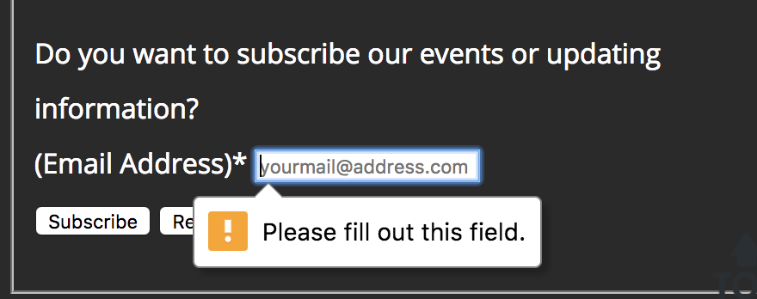

# Studying Page

1. What I tried

+table element

+how to use hover element in the table

+hover and change <td> element background color

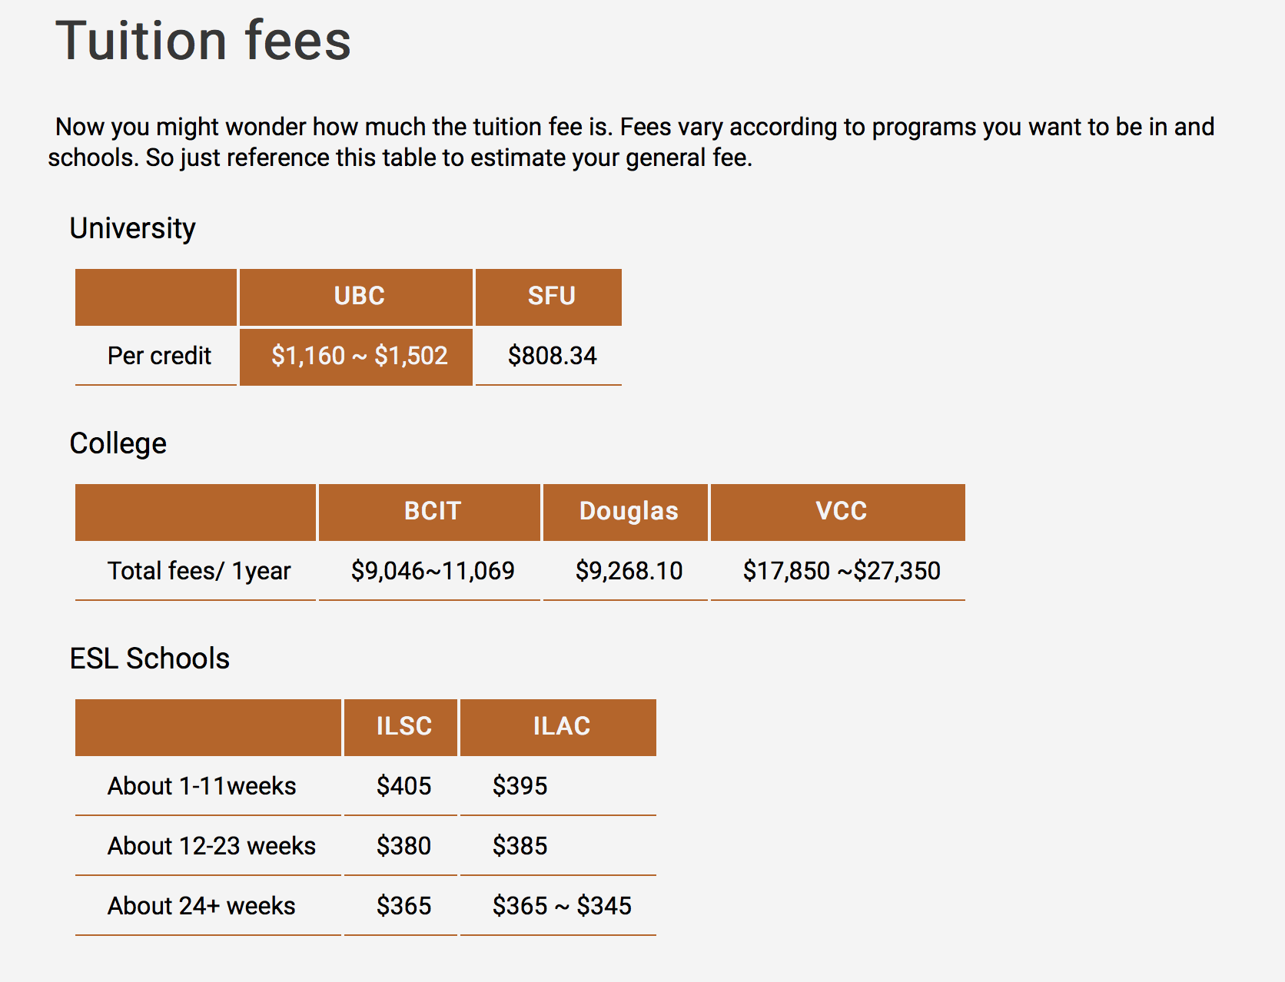

+blackquote.

+ how to make menu bar



+ When mouseover -> change the banner image source

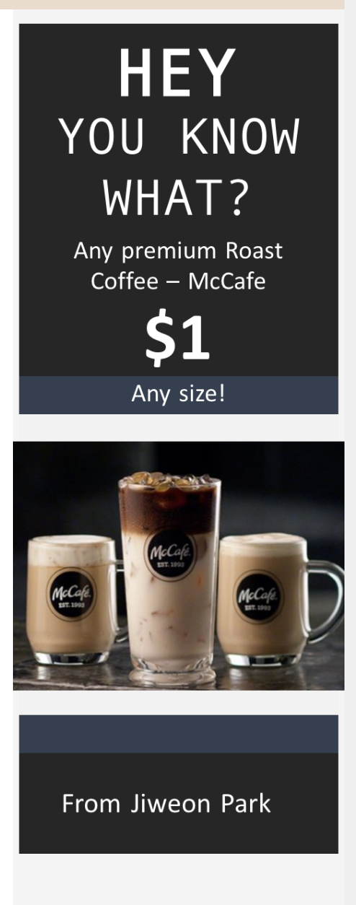 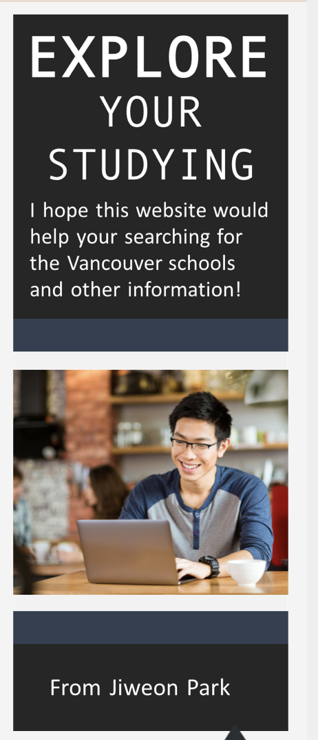

+ vertical menu to navigate inside the current webpage

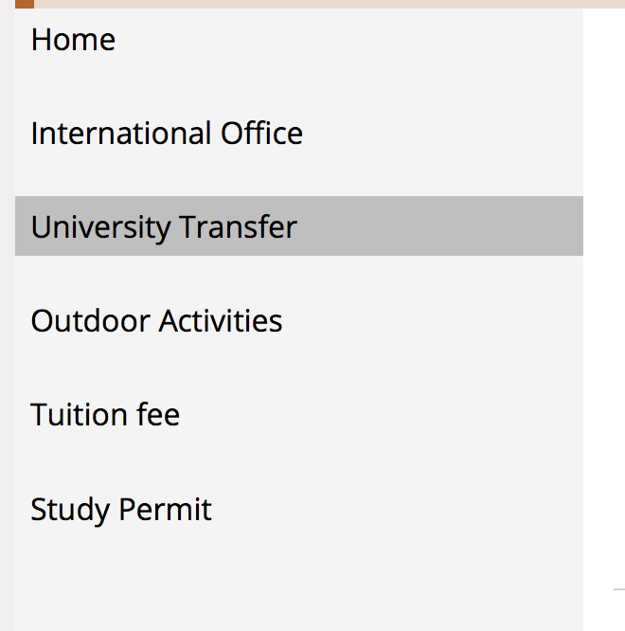

# School Page

+ if click the sentences below, ESL schools are displayed

* 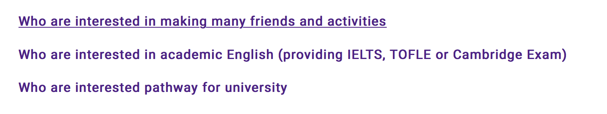

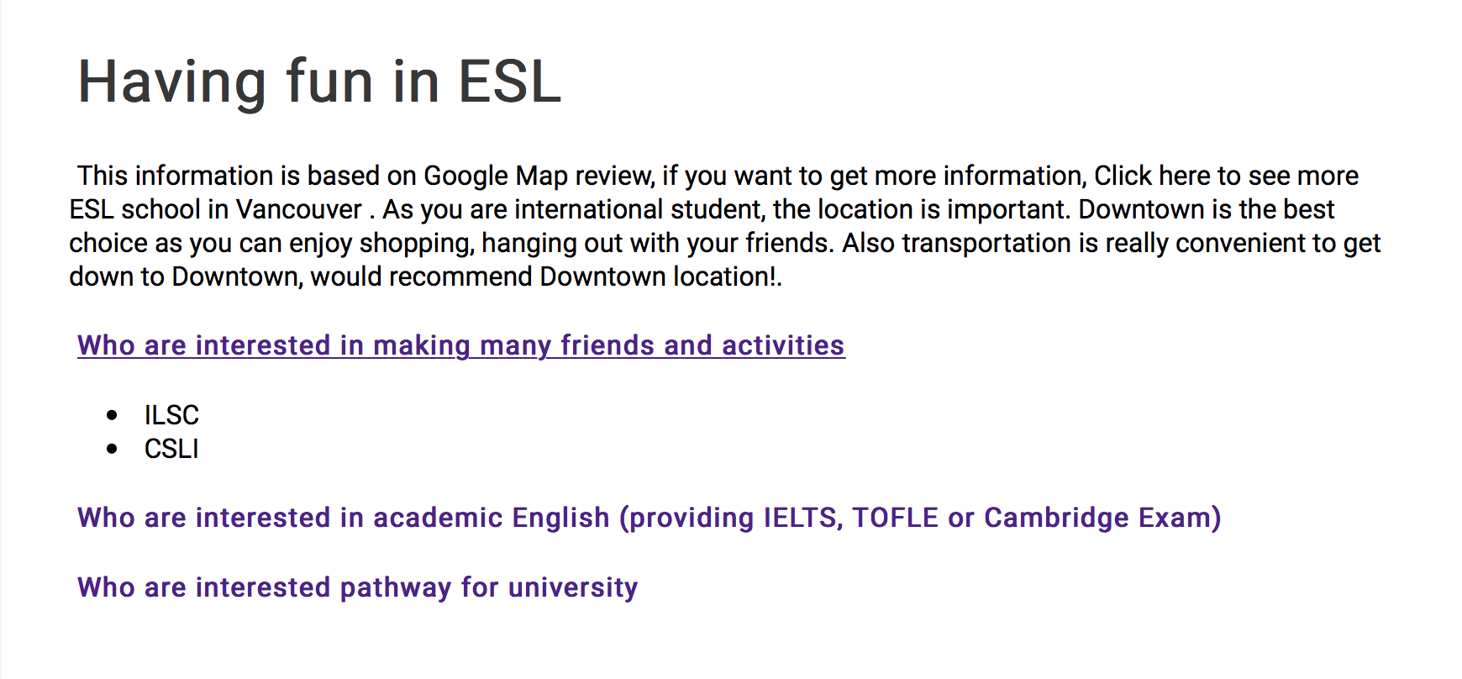

+ if click the ‘show colleges’ button, colleges are displayed



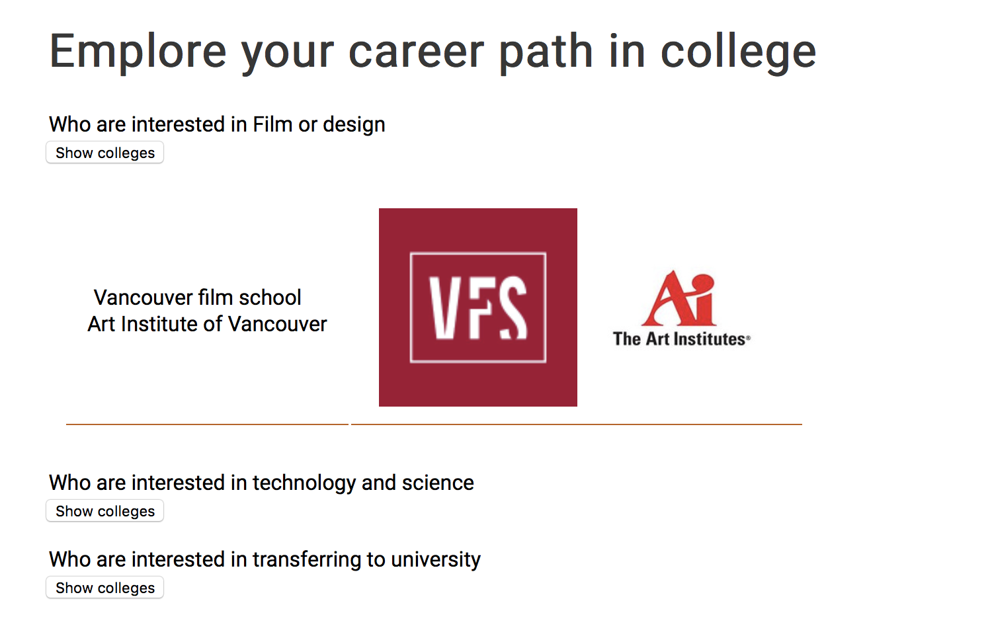

# Living Page

// bookmarks (transportation, Accommodation, Food)

1. What I tried

+<object> and <embed> element to insert a video

+<img> element, image maps for transportation

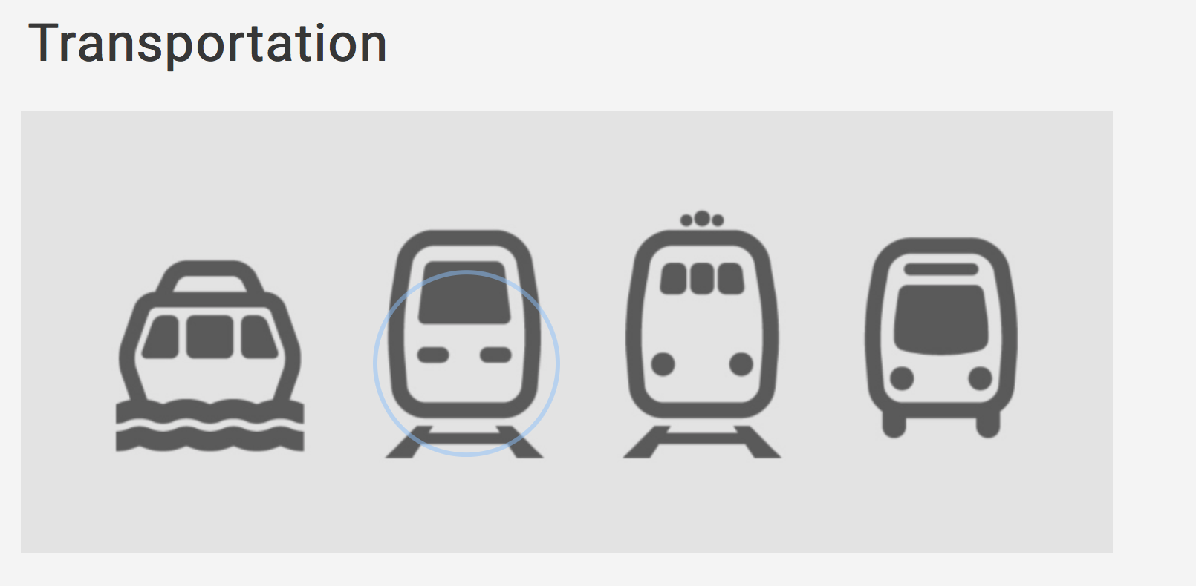

+ The icon of each transportation is linked to schedule websites.

+ Javascript form

Are you suitable for studying in Vancouver?

+If ‘yes’ is selected more than 3, window form pops up

* Good for you to study in Vancouver!!

Otherwise,

* you should take a consideration of studying in Vancouver..

+If radio buttons are not checked more than 3, window form pops up

* you should select at least 3 questions.

# About us page

+ my picture and google map are added

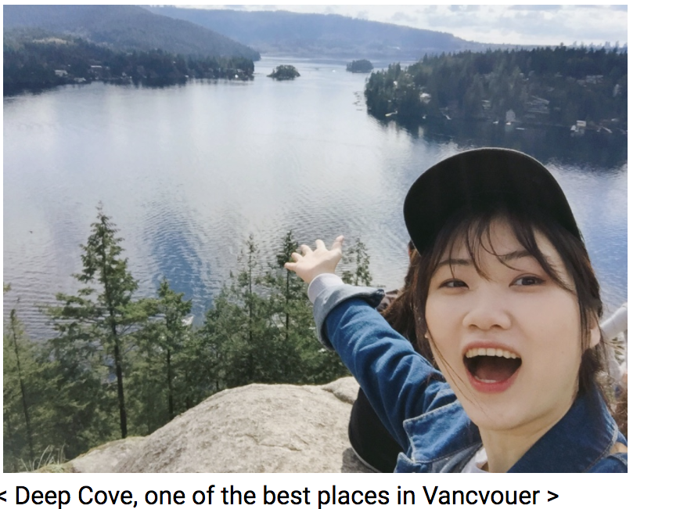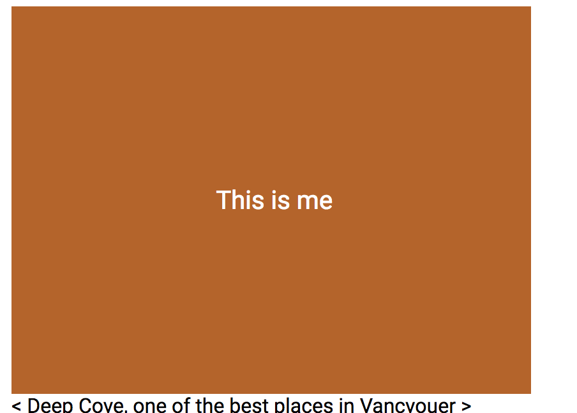

hover -> image overlay

# Summary

1) The design of the web pages

- CSS grid (6fractions)

- subscribe form in footer

- buttons linking to webpages(user-friendly)

- Back to top button

- Advertisement zone

- Expandable paragraph

- Vancouver adaptation test using JavaScript

- Color-changeable table

- vertical & horizontal menu bar

- Highlighting some important words

2) The main HTML/JavaScript/DHTML features that you used

**DHTML :**

- expandable paragraph

- onmouseover, onmouseout (Advertisement)

- menu bar

- innerHTML for the heading in main homepage

-image overlay

**HTML :**

- pseudocode : hover in table (change background and color)

- background image position

- video element

- image navigation

**JavaScript :**

-Read radio button value and display the results (Vancouver adaptation test)

-validation for submit (radio button)

- display expandable paragraph

- text element form validation

-setInterval method in main homepage(2seconds later, displayed)

3) Any features/tools that are not covered in class but have applied in the project

CSS grid area

Background position

Importing google fonts in HTML

Box-shadow

Google map

Email type element (for validating form in footer)

# Source

1. Homepage images

<https://www.google.ca/url?sa=i&rct=j&q=&esrc=s&source=images&cd=&cad=rja&uact=8&ved=0ahUKEwins8Xiit3WAhUURmMKHSGWA7UQjRwIBw&url=https%3A%2F%2Fwww.tourismvancouver.com%2Fapp%2F&psig=AOvVaw1lXzBA-d5z41SZnWGBtem_&ust=1507416648403618> <http://www.hccs.edu/media/09282016_International_Students_banner.jpg>

* 1. <https://orientations.students.ubc.ca/files/styles/ls_04_widescreen/public/Aerials%20Main%20Mall.jpg?itok=F9Nof7MW>
  2. <http://www.myenglishlanguage.com/wp-content/uploads/2012/12/international-student-society.jpg>
  3. <http://treescoffee.com/wp-content/uploads/2015/03/VAN_3348KM-Trees-Organic.jpg> - img3

1. Video source
   1. <https://www.youtube.com/watch?v=UW3CFCBdVLQ)>
2. Address, mail and phone icons for footer
   1. <https://www.flaticon.com/>
   2. <div>Icons made by <a href="http://www.freepik.com" title="Freepik">Freepik</a> from <a href="https://www.flaticon.com/" title="Flaticon">www.flaticon.com</a> is licensed by <a href="http://creativecommons.org/licenses/by/3.0/" title="Creative Commons BY 3.0" target="_blank">CC 3.0 BY</a></div>
   3. <div>Icons made by <a href="http://www.freepik.com" title="Freepik">Freepik</a> from <a href="https://www.flaticon.com/" title="Flaticon">www.flaticon.com</a> is licensed by <a href="http://creativecommons.org/licenses/by/3.0/" title="Creative Commons BY 3.0" target="_blank">CC 3.0 BY</a></div> -map
   4. <div>Icons made by <a href="https://www.flaticon.com/authors/simpleicon" title="SimpleIcon">SimpleIcon</a> from <a href="https://www.flaticon.com/" title="Flaticon">www.flaticon.com</a> is licensed by <a href="http://creativecommons.org/licenses/by/3.0/" title="Creative Commons BY 3.0" target="_blank">CC 3.0 BY</a></div> -map
3. Image overlay css source

:W3C school

https://www.w3schools.com/howto/howto_css_image_overlay.asp